Technical Report UMTRI-2016-* September, 2016

s

**Instructions for Using the UMTRI Expressway Scenario Creation Software for the NADS Minisim**

Raymond Pressly

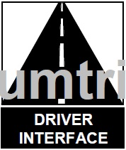

Technical Report Documentation Page

|  |  |  |  |  |  |  |
| --- | --- | --- | --- | --- | --- | --- |
| 1. Report No.  UMTRI-2016-* | 2. Government Accession No. | | | 3. Recipient’s Catalog No. | | |
| 4. Title and Subtitle  Instructions for Using the UMTRI Expressway Scenario Creation Software for the NADS MiniSim | | | | 5. Report Date  September 2016 | | |
| 6. Performing Organization Code  none | | |
| 7. Author(s)  Raymond Pressly | | | | 8. Performing Organization Report No.  none | | |
| 9. Performing Organization Name and Address  The University of Michigan  Transportation Research Institute (UMTRI)  2901 Baxter Road, Ann Arbor, MI 48109-2150 USA | | | | 10. Work Unit no. (TRAIS) | | |
| 11. Contract or Grant No.  none | | |
| 12. Sponsoring Agency Name and Address  none | | | | 13. Type of Report and Period Covered  May 2016 – September, 2016 | | |
| 14. Sponsoring Agency Code | | |
| 15. Supplementary Notes | | | | | | |
| 16. Abstract  Research studies involving the testing of vehicle controls, displays, and warning systems often involve the use of driving simulators. The creation of driving scenarios is a lengthy and costly process.  In this project, software was developed to generate driving scenarios based on a set of parameters given by the user. The user inputs a two lane expressway .scn file that contains the subject vehicle. The user then specifies the length of the scenario in number of trials (a 5000 ft. section of highway). Then the interface allows for major scenario settings to be changed (follow/lead vehicle generation, generation of opposing traffic, etc.) as well as manipulation of traffic over each trial (shoulder/left lane vehicle control and follow/lead vehicle control).  The user then can save the new .scn file once satisfied with their settings. The .scn can immediately be placed onto the Minisim to be used or can be opened in ISAT to be modified further. | | | | | | |
| 17. Key Words | | | 18. Distribution Statement  No restrictions. This document is available to the public through the National Technical Information Service, Springfield, Virginia 22161 | | | |
| 19. Security Classify. (of this report)  (None) | | 20. Security Classify. (of this page)  (None) | | | 21. No. of pages  ** | 22. Price |

**Form DOT F 1700 7 (8-72) Reproduction of completed page authorized**

# Table of Contents

Introduction 4

Using the Software 5

Loading and Saving 5

Major File Settings 6

Trial Manager 10

Updating Software on the MiniSim 6

Creating Input Files 7

Extending and Shortening the Roadway 5

Names of Created Objects 7

Development of Software 8

**Introduction**

The NADS Minisim is a 3D driving simulator used to study driver controls, visuals, and information systems in vehicles. In order to conduct research, a driving scenario must be created. The scenario is then loaded onto the Minisim for test subjects to drive in while data is collected. A typical driving scenario for a study takes approximately two months to be created and tested before being used in a study. This process is much longer than the testing itself, therefore a more efficient process of creating driving scenarios was needed.

The purpose of this project was to develop a program that creates scenario templates for the Minisim based on a series of parameters defined by the user. This program would accelerate the creation of driving scenarios from a period of months to possibly less than a week. The resulting software named the “Expressway Scenario Interface” is a single window, file in/file out, interface for creating driving scenarios. The software is currently set up to control a two lane, bidirectional highway scenario but can be modified to handle more lanes. The length of the scenario can be changed by specifying the number of trials in the scenario and giving an input scenario to match the number of trials given.

The Expressway Scenario Interface was designed with the idea that general elements of the driving scenario would be created and test specific elements would be left to the user’s creation. The first set of general parameters that the user can control are the major file settings. These settings are global settings for the entire scenario and include: follow and lead vehicle instructions across the entire experiment, the creation of blind spot warnings for the subject, the customization of the frontal crash warning, and the generation of opposing lane traffic.

The second set of parameters the user can control are the instructions across each trial. This is done by use of the trial manager: a series of buttons allowing the user to iterate back and forth over trials, making changes to the scenario when necessary. The trial manager allows the user to create left lane and road side vehicles as well as alter the follow and lead vehicles behavior over the period of the trial.

The scenarios created by the software are ready to be tested on the Minisim or to be altered in ISAT after being saved. This allows the researcher to create more specific scenarios per their research. The following sections cover how to use the software, what the software does directly, and updating/installing the software on the Minisim system.

**Using the Software**

This section goes in depth on how to use each part of the interface to meet the user’s specific needs. This section will also describe what is added to the scenario when a certain option is selected from the interface.

**Loading and Saving Files**

A file must be loaded into the Expressway Scenario Interface in order to start building an expressway scenario. A new file must also be saved once the interface has processed all user inputs. This process is handled by the **File Manager** in the lower left corner of the interface (see Figure 1).

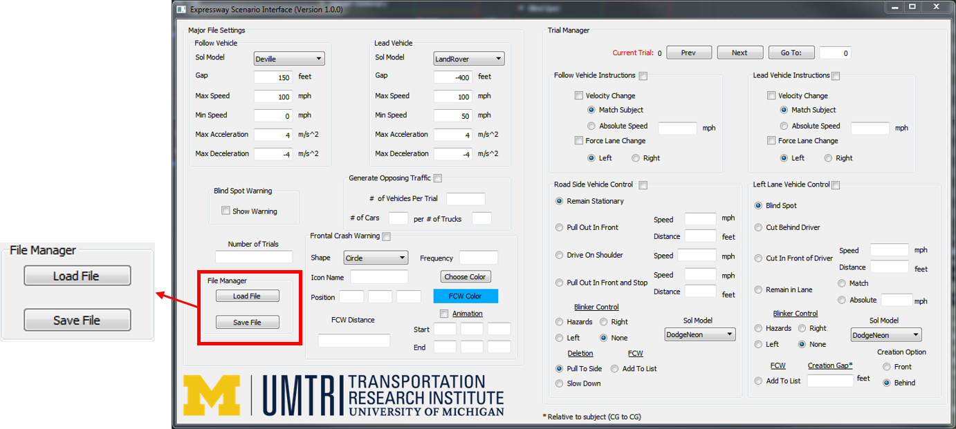

Figure 1. The location of the **File Manager** within the interface.

Loading a file into the interface is the first step taken when using the interface. This is due to the fact that the Expressway Scenario Interface was created by reverse engineering objects found in scenario files created through ISAT. There may be bugs in the current version of the Expressway Scenario Interface due to this design process. Thus it is recommended to load a basic input scenario file and not a complex or almost complete file in fear of losing data when the interface reads the file.

To begin loading a file, click the **Load File** button within the **File Manager** group box. The user then can navigate to the desired input file to the system. The input file must include the subject vehicle’s starting location and orientation. To insert the external driver in the scenario, begin by opening or creating a new scenario file in ISAT. If creating a new file, the necessary .bli file ES175.bli can be found in the folder ES175Files in the Minisim pathway “insert pathway here”. If using the base file included with the interface, open the file base.scn found in the Minisim pathway “insert pathway here”. With the .scn file now open, navigate to **Insert > External Driver** and place the external driver on beginning of the roadway.

The user can now begin making changes to the interface selections once the base scenario file has been loaded in. To save a file when completed, click on the **Save File** button in the **File Manager** group box. This will prompt the user to select a location to place the new file.

**Major File Settings**

The Major File Settings are global settings throughout the entirety of the scenario. These settings are important for controlling visual displays, lead and follow vehicle instructions, and opposing traffic.

*Follow and Lead Vehicle*

The **Follow Vehicle** group box is used to set the instructions of the follow vehicle. The parameters that the user can define are very similar to the setup of the follow vehicle in ISAT (see figure 2). The **Sol Model** drop down menu is used to select the vehicle type and a random color is selected by the interface for that vehicle. The user can then specify the maximum gap that is allowed between the follow vehicle and the subject’s vehicle in the **Gap** line edit box. The minimum and maximum speed of the follow vehicle can be altered in the **Min Speed** and **Max Speed** line edits respectively. The last two parameters defined by the user are the max acceleration and max deceleration of the follow vehicle (the max deceleration must be a negative number).

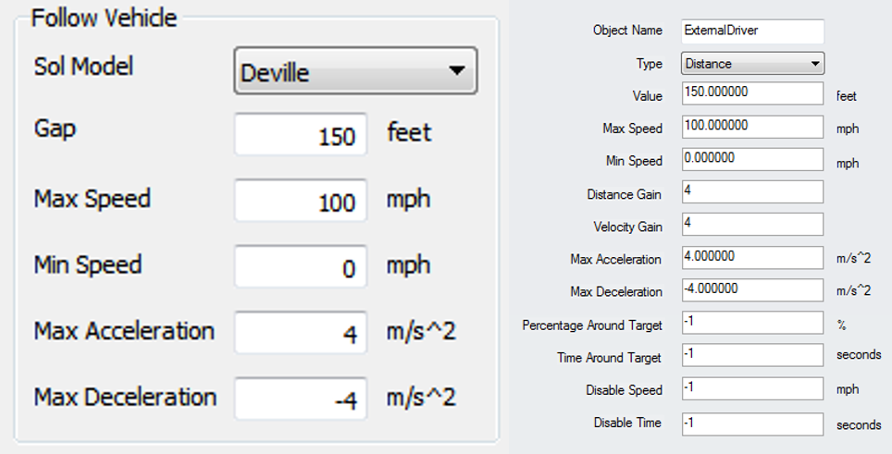

Figure 2. Side by side comparison of **Follow Vehicle** group box against ISAT MaintainGap.

The resulting objects added to the scenario file will be the follow vehicle (an ADO) itself and an Expression Trigger to maintain the gap between the follow vehicle and external driver. The Expression Trigger has a “MaintainGap” Set Dial that matches the settings defined in the **Follow Vehicle** group box. The **Lead Vehicle** group box matches the **Follow Vehicle** group box except that the **Gap** group box must be a negative value for the lead vehicle.

*Generate Opposing Traffic*

The **Generate Opposing Traffic** group box is used to create opposing traffic as the driver travels through the scenario. Traffic will only be generated when the **Generate Opposing Traffic** check box is selected. When this option is selected, the user must specify the number of vehicles per trial on the opposing expressway and the number of cars per the number of trucks in the trial. The number of vehicles per trial is used to define the level of traffic in the opposing lane. The number of cars per truck ratio is used to control the type of traffic that the subject will see.

The interface will generate the specified number of vehicles per trial with each vehicle being randomly selected to be a truck or car (dependent upon the car to truck ratio), placed in a randomly selected lane, placed in a random position in that section of the lane, and with a color randomly selected based on the vehicles model. Below are recommendations on levels of traffic for scenarios where the trial length is 5000 ft.

|  |  |
| --- | --- |
| **Level of Traffic** | **# of Vehicles Per Trial** |
| Light | 1-9 |
| Moderate | 10-19 |
| Heavy | 20-24 |
| Extremely Heavy | 25+ |

Table 1. Levels of traffic and recommended numbers of vehicles per trial.

*Blind Spot Warning*

The **Blind Spot Warning** is a visual display that is triggered when a vehicle is in the driver side or passenger side blind spot. This is done by displaying a graphic in the driver side or passenger side mirror when the subject drives past a stationary vehicle or a vehicle is within a certain distance of the driver. The interface will only display a blind spot warning for the following trial situations except for the left lane **Cut Behind Driver Option**.

Selecting the **Blind Spot Warning** option will create a graphic for the right blind spot warning named “BSW_Right_Graphic” and another graphic for the left blind spot warning named “BSW_Left_Graphic”. These graphics can be customized further if the user wishes. The blind spot warning variables are initialized by the Time Trigger “BSWInit” where the “Right_Blind” and “Left_Blind” variable are set to 0. Four other triggers control when the left and right graphics are displayed throughout the scenario. The right blind spot warning is displayed whenever the “Right_Blind” variable is 1 and hidden otherwise. The left blind spot warning is displayed the same way except with “Left_Blind” being the controlling variable. Table 2 below describes how the graphics are triggered for different trial scenarios.

|  |  |
| --- | --- |
| **Trial Situation** | **How Graphic is Triggered** |
| Road Side – Remain Stationary | Roadpad Trigger placed alongside vehicle to activate graphic. |
| Road Side – Pull Out in Front | Expression Trigger that is activated when the car is within 36 ft. of the subject. The Expression Trigger is created when the Road Side vehicle changes lanes for the second time. |
| Road Side – Drive On Shoulder | Expression Trigger that is activated when the car is within 36 ft. of the subject. |
| Road Side – Pull Out In Front and Stop | Expression Trigger that is activated when the car is within 36 ft. of the subject. The Expression Trigger is created when the Road Side vehicle stops. |
| Left Lane – All Options | Expression Trigger that is activated when the car is within 36 ft. of the subject. |

Table 2. How blind spot warnings are activated.

*Frontal Crash Warning*

**Names of Created Objects**

|  |  |
| --- | --- |
| **Name** | **Details** |
| “FV” | Follow vehicle. |
| “LV” | Lead vehicle. |
| “FV_Keep_Distance” | Expression Trigger to maintain follow vehicle gap. |
| “LV_Keep_Distance” | Expression Trigger to maintain lead vehicle gap. |
| “OppositeX_Y” | Opposite expressway vehicle where X is the trial number and Y is how many opposing lane vehicles come before this vehicle. |
| “BSW_Right_Graphic”/ “BSW_Left_Graphic” | Graphics for the blind spot warnings. |
| “BSWRightOff”/ “BSWRightOn” | Activating and deactivating the right blind spot graphic. |
| “BSWLeftOff”/ “BSWLeftOn” | Activating and deactivating the left blind spot graphic. |
|  |  |
|  |  |
|  |  |